Lab Assignment# 1

Name: Muhammad Sohail
Registration_Numbrt: FA24-BSE-105
Subject: Operating System.

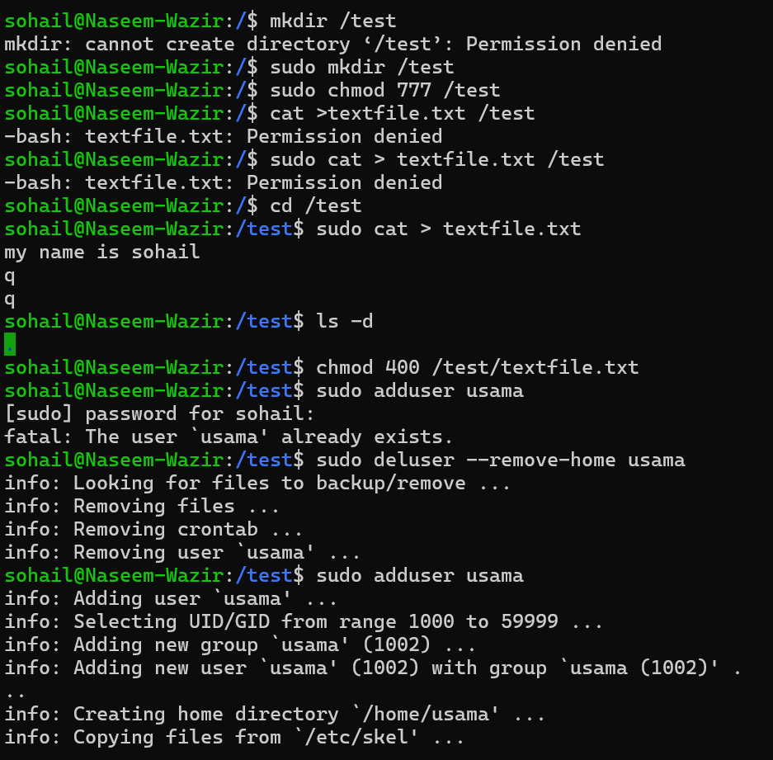

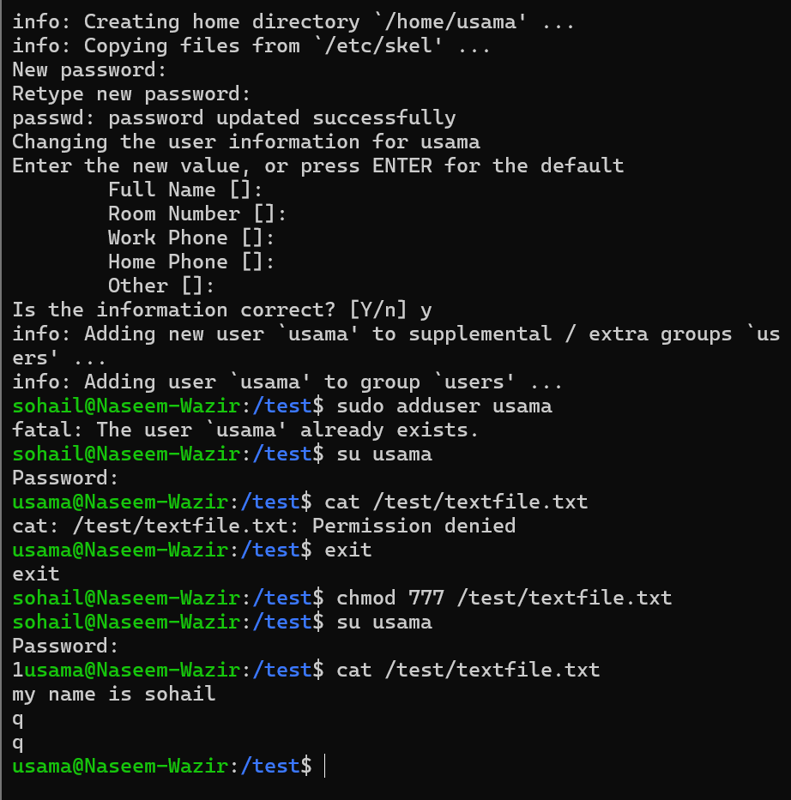

Activity#2
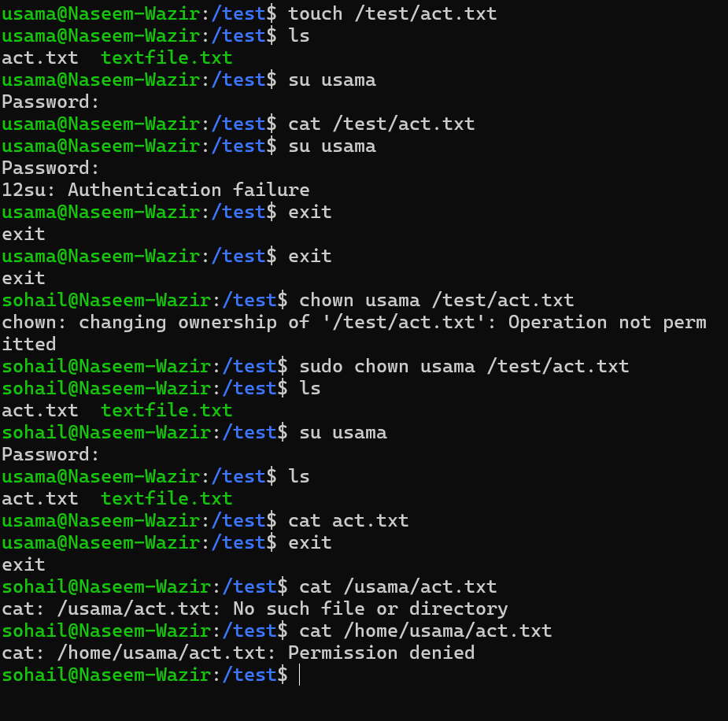

Activity#3
I have done once on the lab , now again I will upgrade the system so that’s why I can not do this activity ,as I have done these all tasks in lab but did not save in the word file . I am making this file again as for assignment.

Graded Lab Task:#3
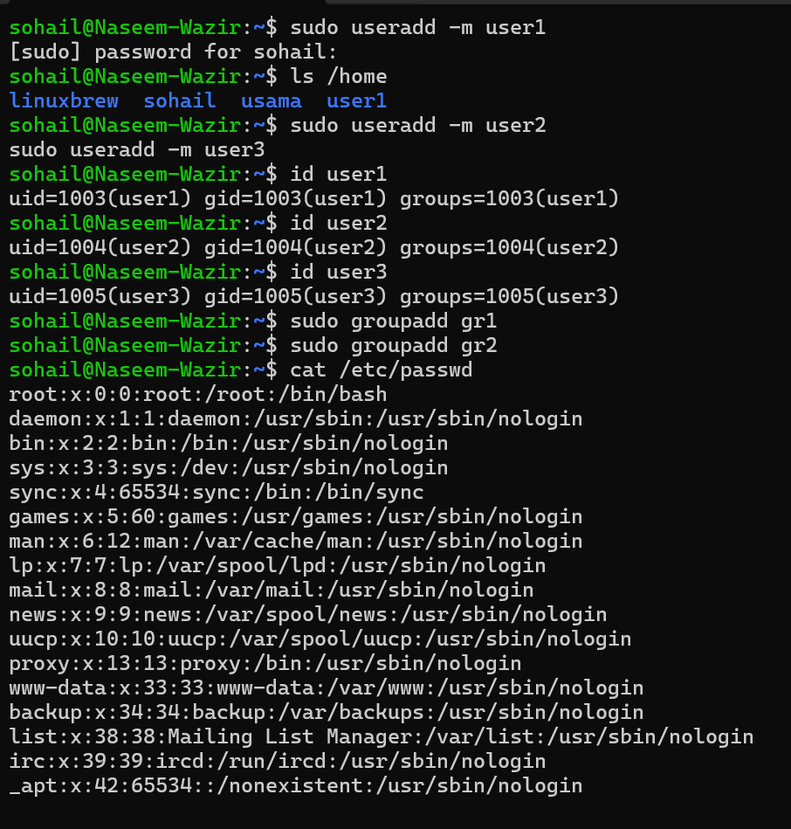

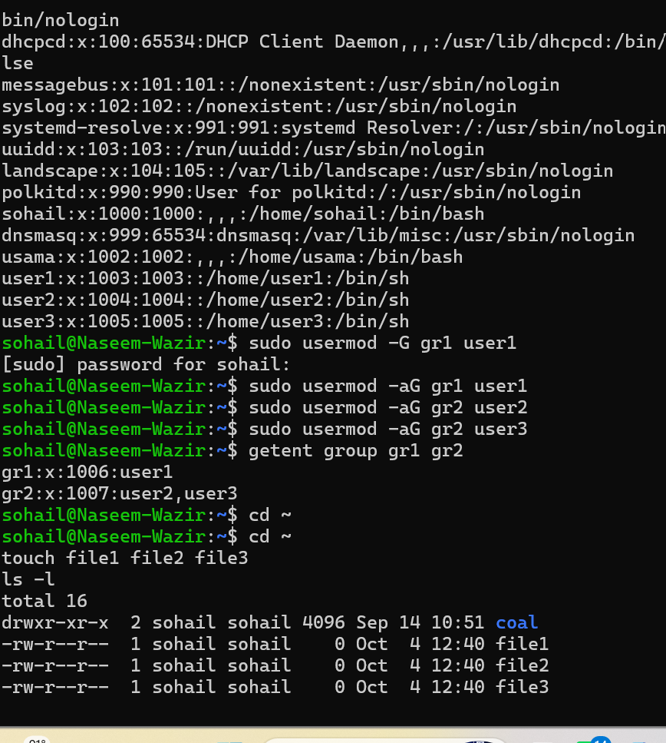

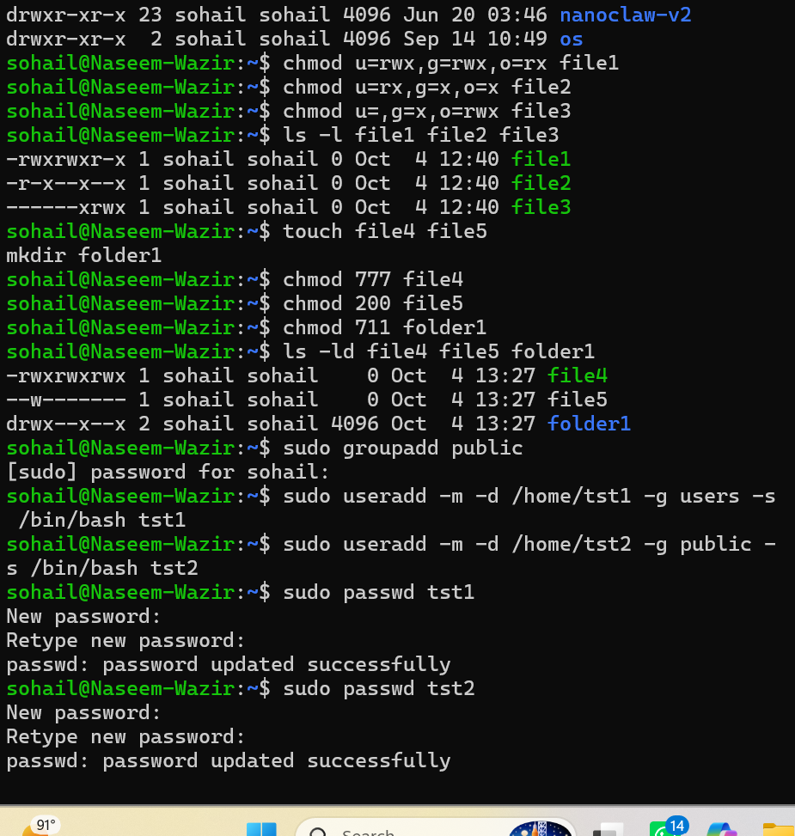

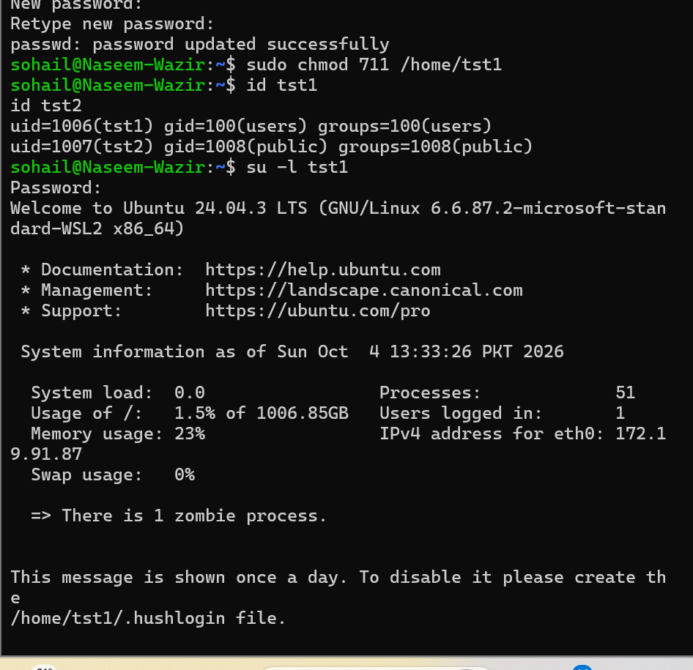

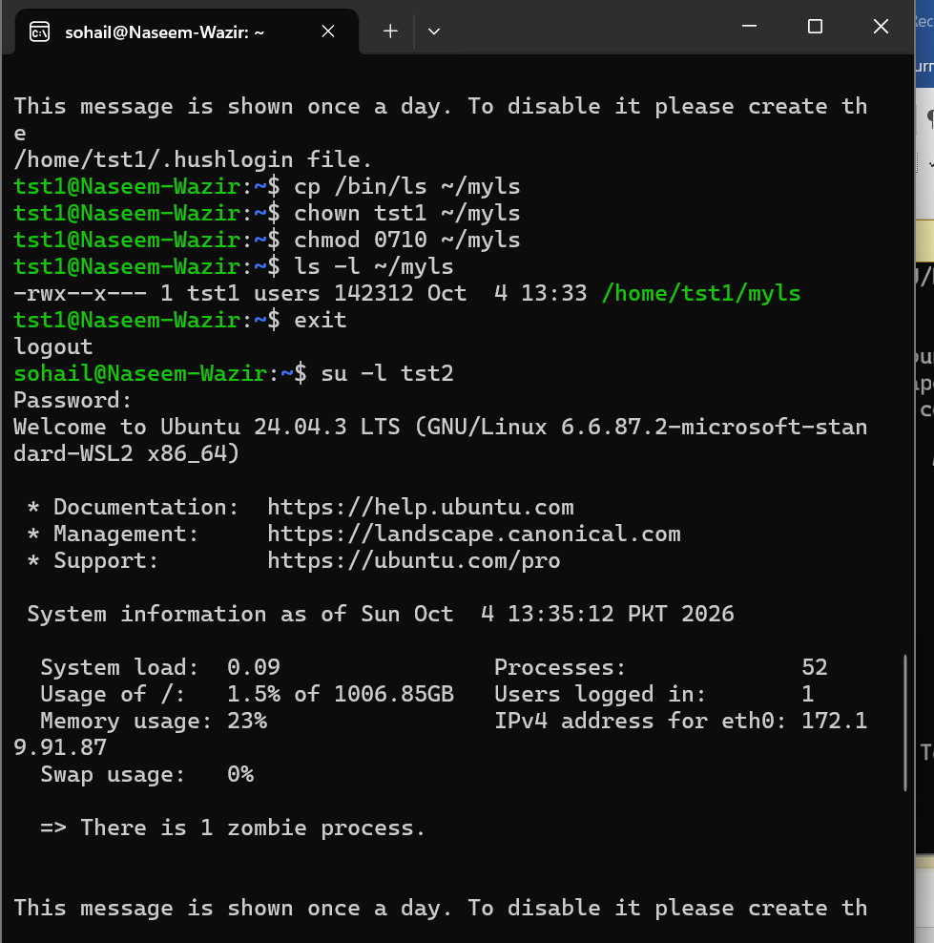

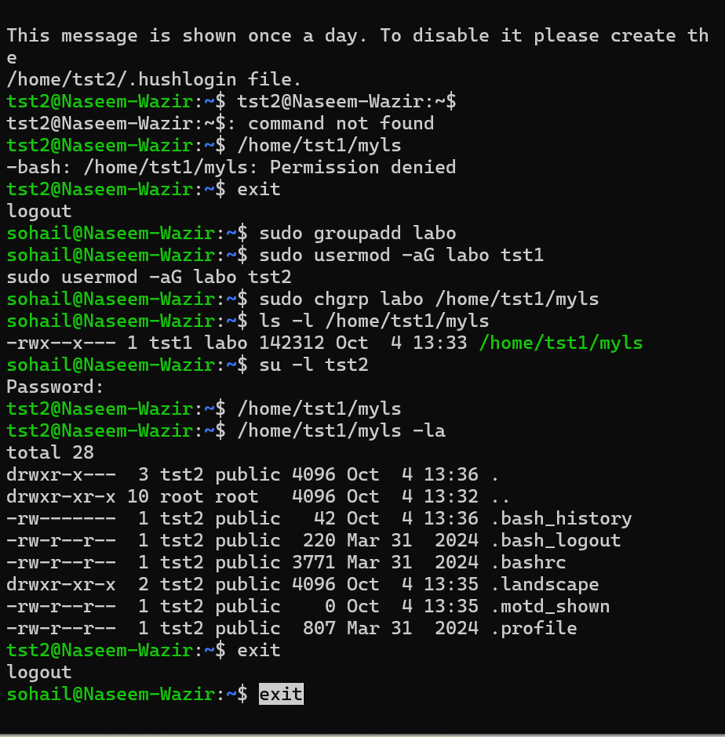
Lab#4:
Task1:
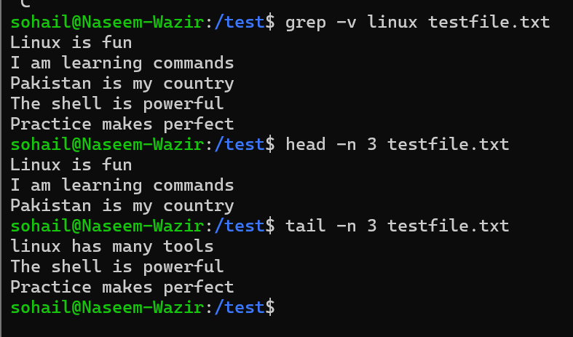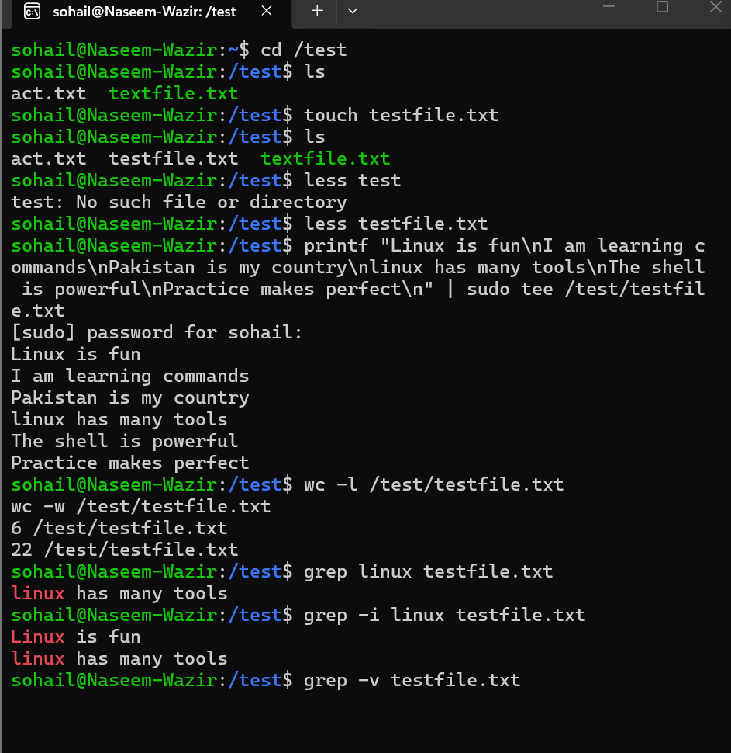

Task#2:
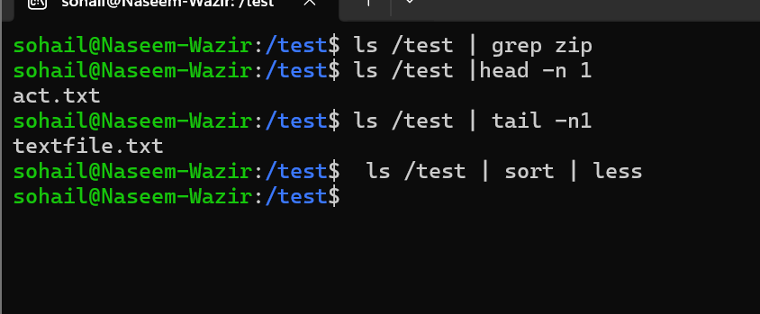

Task#3:
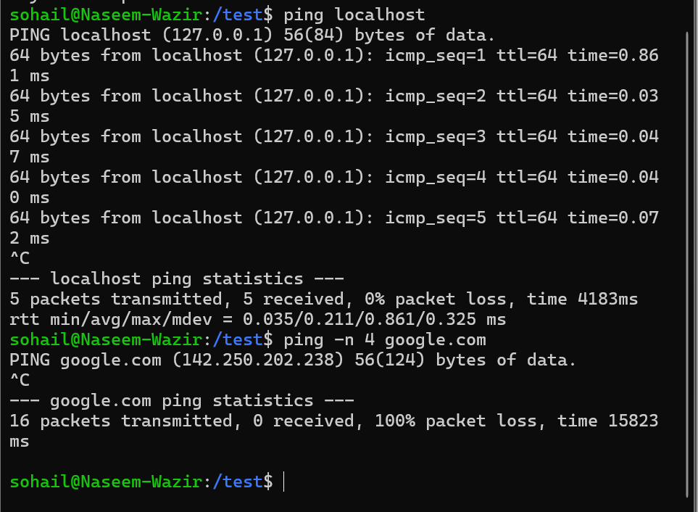

Graded Lab Task:
1: Use sort and unique command to sort a file and print unique values.

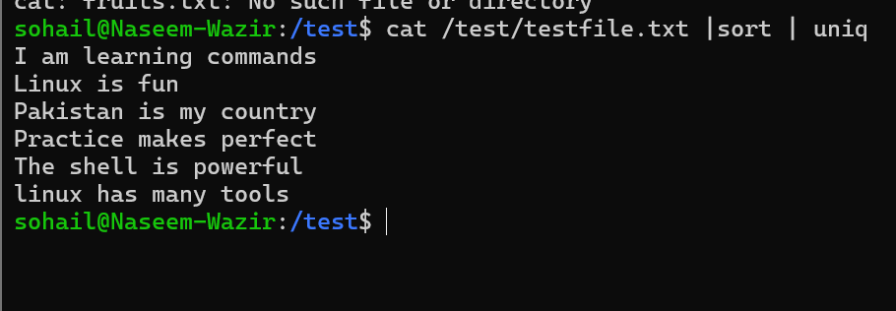

2: Use head and tail to print lines in a particular range in a file.

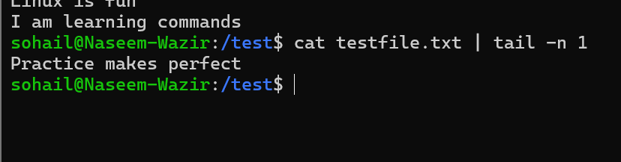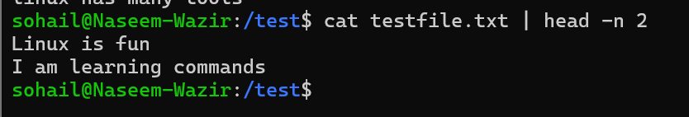

3:U se ls and find to list and print all lines matching a particular pattern in matching files.
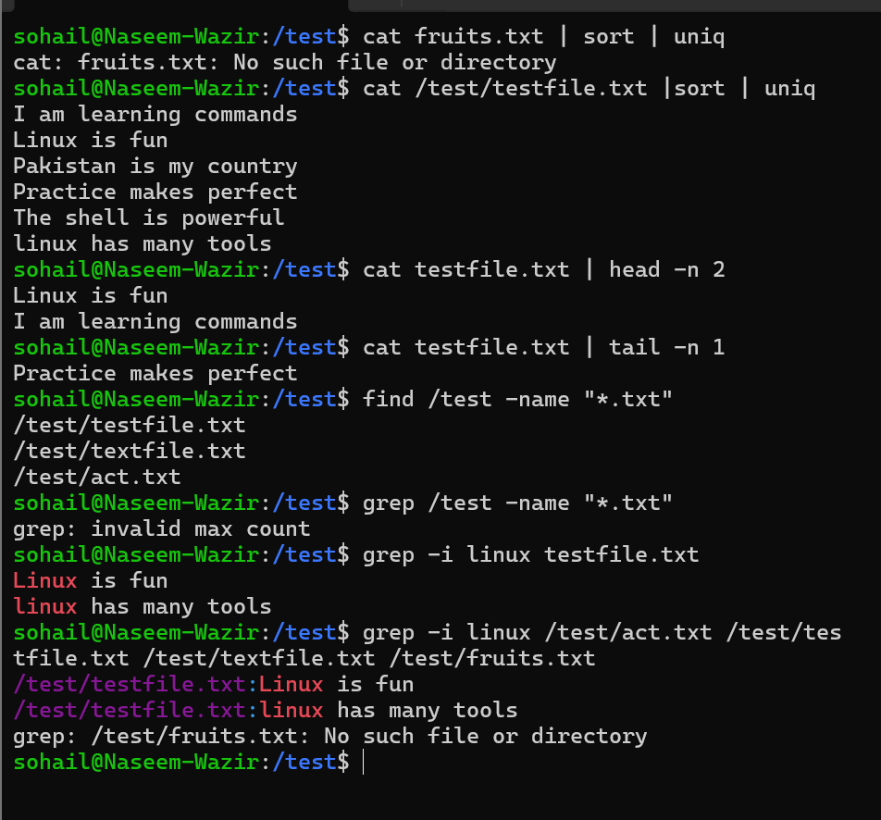

4:

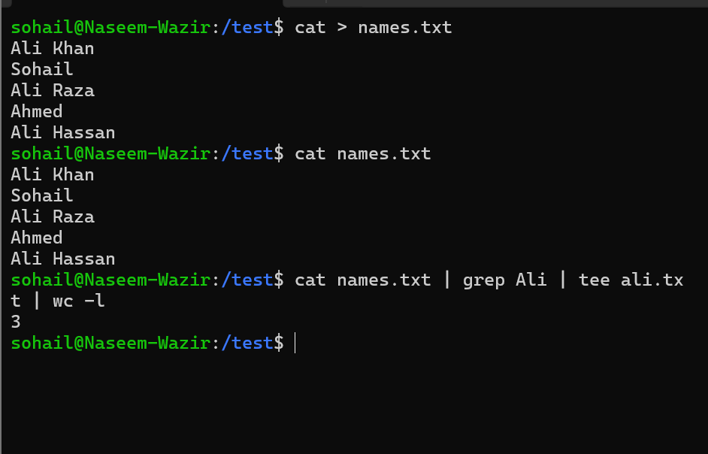
5: 